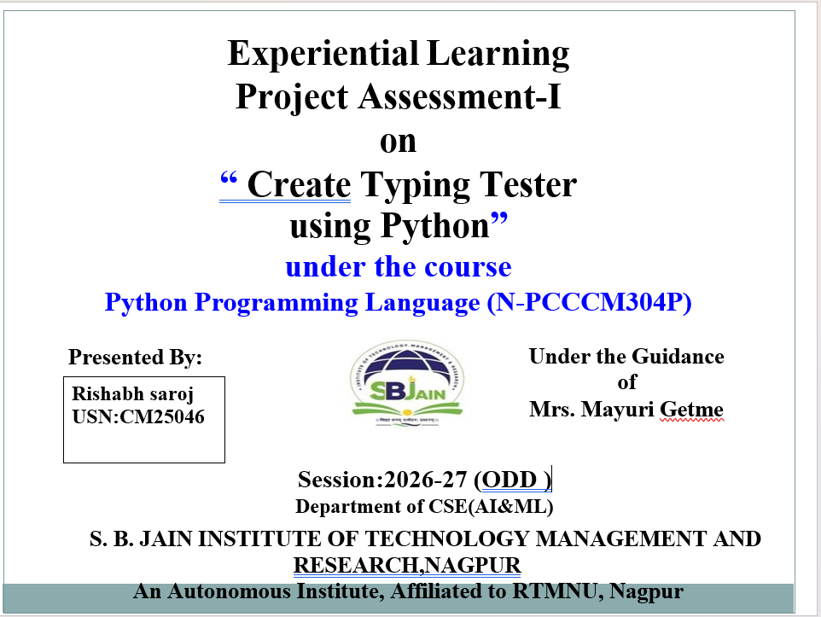
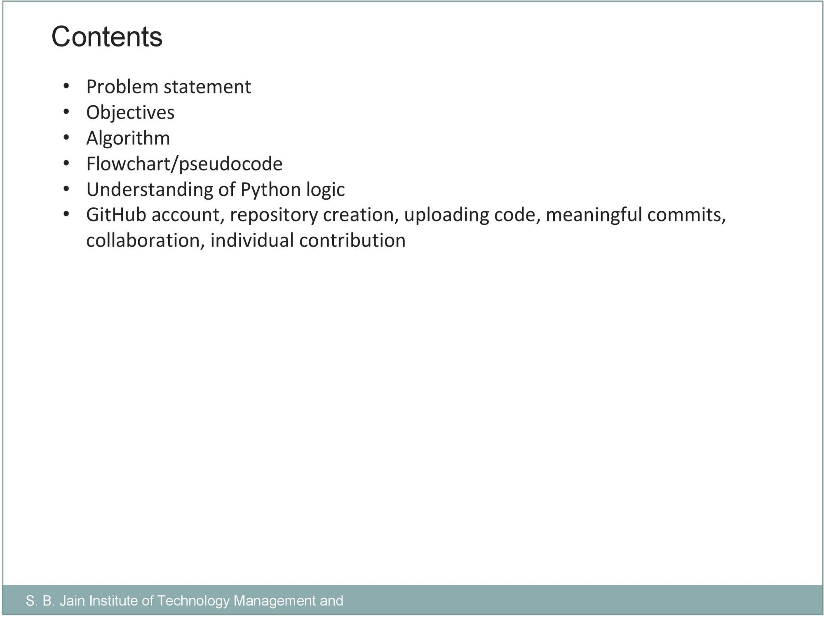


•
Problem Statement:
Create Typing Tester using Python
Develop a Python
-
based Typing Tester that measures a user's typing speed and
accuracy. The application should display a predefined paragraph or sentence, record
the time taken by the user to type the text, compare the typed input with the original
text, and calculate performance metrics such as Words Per Minute (WPM) and
accuracy percentage. The system should provide feedback on typing performance
and allow users to attempt multiple tests for practice and improvement.

Objectives:
To develop a simple typing speed testing application using Python.
To measure the user's typing speed in
Words Per Minute (WPM)
.
To calculate the user's typing accuracy.
To provide performance feedback to the user.
To allow multiple attempts for practice and improvement.
To understand and implement basic Python programming concepts.
To create a
user
-
friendly and easy
-
to
-
use

typing test interface.
To track and evaluate the user's
typing performance over multiple attempts
.

To help users
identify typing mistakes

and improve their accuracy.
To provide
instant performance results and feedback
.


Alogrithm
:
1.
Start the program.
2.
Display a predefined paragraph/sentence to the user.
3.
Record the starting time using the timer.
4.
Ask the user to type the displayed text.
5.
Record the ending time when the user finishes typing.
6.
Calculate the total time taken.
7.
Compare the original text with the typed text character by character.
8.
Count the correct characters and calculate the accuracy percentage.
9.
Calculate Words Per Minute (WPM) using the typing time and number of
characters.
10.
Display WPM, accuracy, time taken, and performance feedback.
11.
Ask the user whether they want to attempt another test.
12.
If yes, repeat the test; otherwise, end the program.

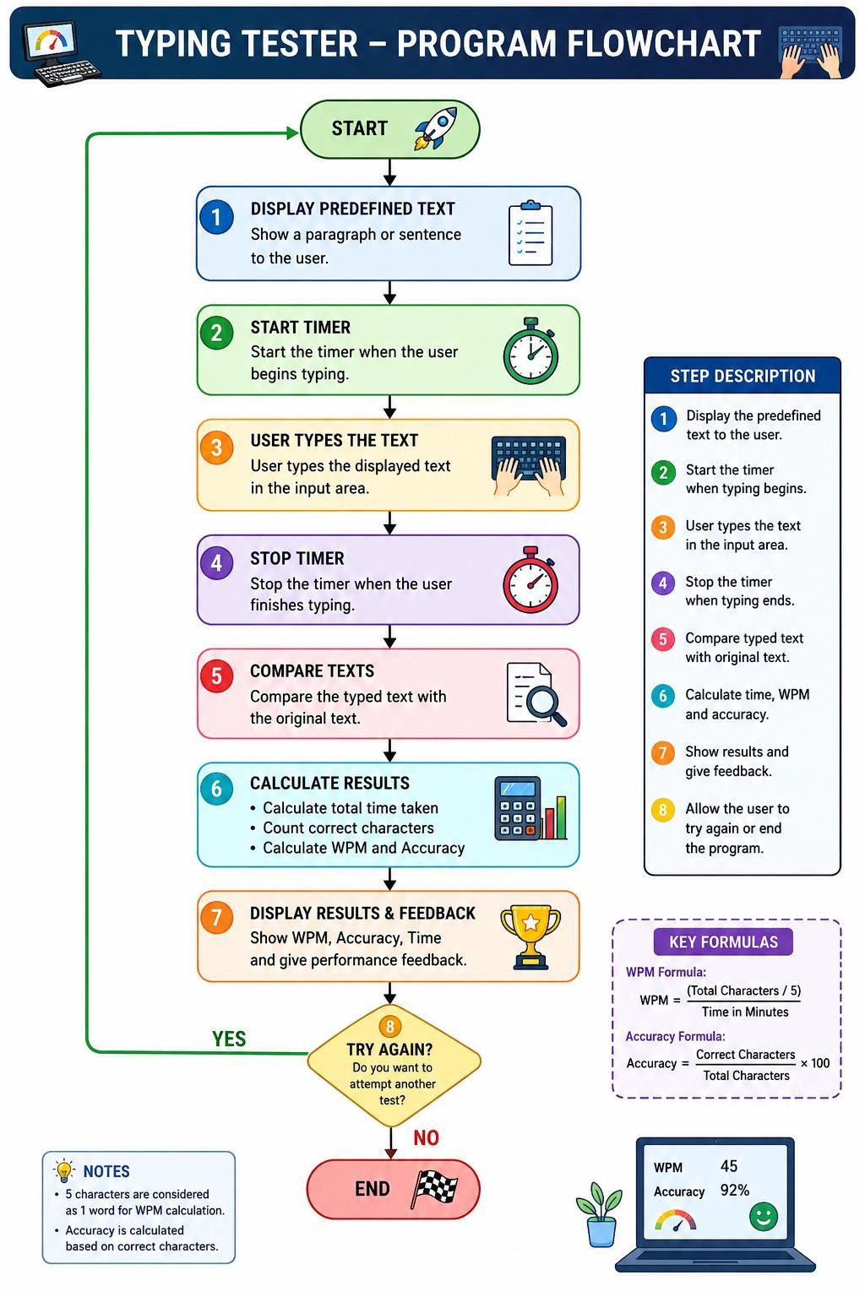
Flowchart/pseudocode
:

Understanding of Python logic:
Variables: Used to store text, time, score, and accuracy values.
Input:
input()

is used to take the user's typed text.
Strings: Used to store and compare the original paragraph with the user's input.
Time Module: The
time

module is used to calculate how long the user takes to type.
Loops: Used to repeat the typing test for multiple attempts.
Conditional Statements:
if
-
else

is used to check correct characters and provide

feedback.
Functions: Used to divide the program into smaller, reusable tasks.
Calculations: Used to calculate WPM and accuracy percentage.
String Comparison: Each character of the original and typed text is compared to find
mistakes.
Output:
print()

displays the final WPM, accuracy, time, and feedback.

